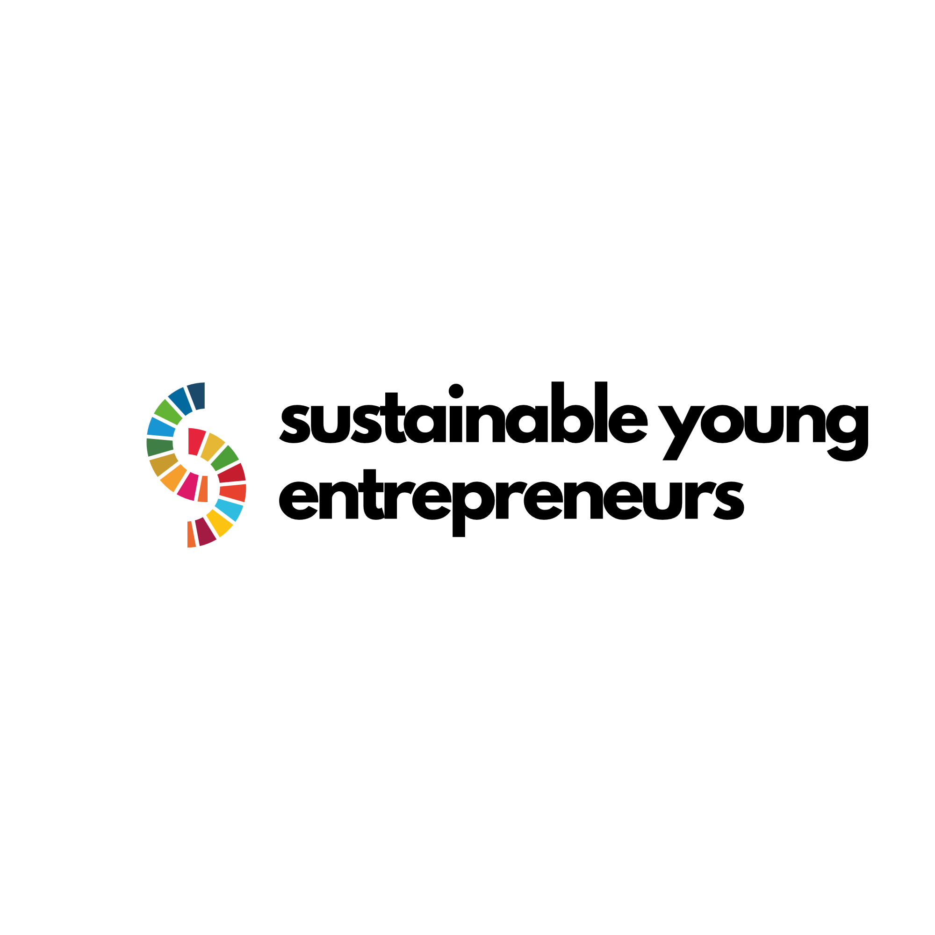

**Sustainable and Social Entrepreneurship for Youth (SUSE) Programme**

**A Guide to Understanding Environmental Degradation in Business**

All rights reserved.

Copyright

© Copyright 2023 Sustainable and Social Entrepreneurship for Youth

**Partner Members:**

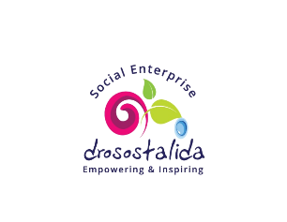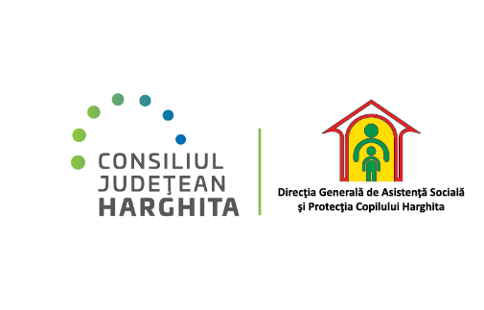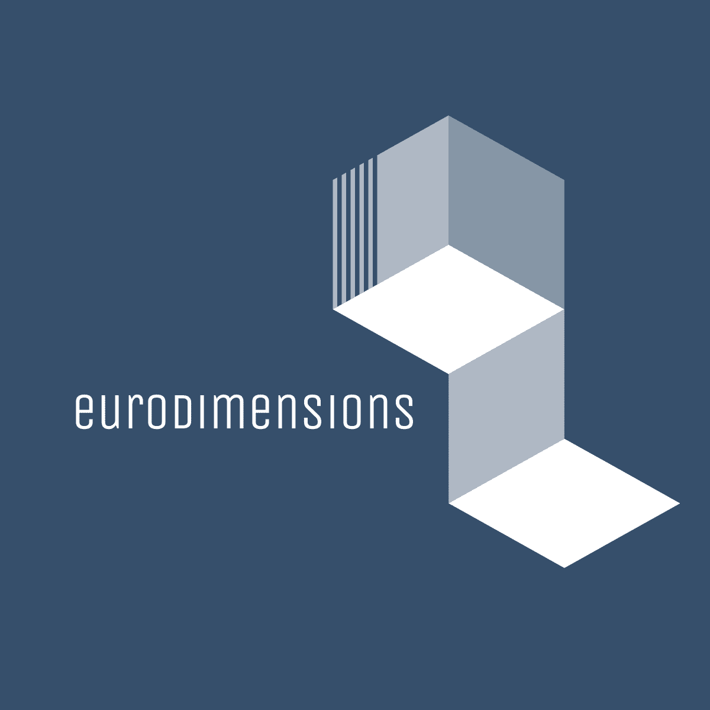

*Funded by the European Union. Views and opinions expressed are however those of the author(s) only and do not necessarily reflect those of the European Union or the European Education and Culture Executive Agency (EACEA). Neither the European Union nor EACEA can be held responsible for them.*

**Content**

Introduction 4

1.Types of environmental degradation 4

Pollution 4

Resource depletion 5

Habitat Destruction: 6

Climate Change 7

Understanding Climate Change 7

Impacts of Climate Change 7

2.The role of Businesses in Environmental Degradation 8

Industrial Waste 8

Emissions 8

Overconsumption of Resources 9

Land Use 9

3.Impact of Environmental Degradation on Businesses 9

4.Strategies for Businesses to Address Environmental Degradation 11

5.Resources for Further Learning: 12

# Introduction

Environmental degradation refers to the deterioration of the environment through depletion of resources such as air, water, and soil; the destruction of ecosystems; habitat destruction; the extinction of wildlife; and pollution. In a business context, environmental degradation is often a result of industrial activities and processes that have not adequately considered environmental impacts. It's crucial for businesses to recognize their role in environmental degradation and take proactive steps to mitigate negative impacts. By adopting more sustainable practices, not only can businesses avoid the risks associated with environmental degradation, but they can also enjoy enhanced reputation, legal compliance, operational efficiencies, and potentially access new markets and customer segments interested in sustainable products and services.

# 1.Types of environmental degradation

## Pollution

Pollution is a critical environmental issue that requires concerted efforts from individuals, communities, governments, and businesses to address. While it poses significant challenges to health and the environment, the growing awareness and advancements in technology provide pathways for reducing and managing pollution effectively. As society continues to develop and industrialize, sustainable and innovative solutions are increasingly necessary to ensure a healthy and stable environment for future generations.

1. **Air Pollution:**
   * **Sources:** Emissions from industrial processes, vehicular exhaust, burning of fossil fuels, agricultural activities, and waste incineration.
   * **Impacts:** Respiratory and cardiovascular diseases in humans, acid rain, global warming, and damage to wildlife and habitats.
2. **Water Pollution:**
   * **Sources:** Discharge of industrial and agricultural chemicals, oil spills, untreated sewage, and littering.
   * **Impacts:** Contaminated drinking water, destruction of aquatic ecosystems, and the disruption of food chains.
3. **Soil Pollution:**
   * **Sources:** Use of pesticides and fertilizers in agriculture, industrial spills, improper waste disposal, and mining activities.
   * **Impacts:** Reduced soil fertility, altered soil structure, toxic plants and food, and water contamination through soil leachate.
4. **Noise Pollution:**
   * **Sources:** Industrial and construction activities, transportation systems, urban development, and recreational activities.
   * **Impacts:** Hearing loss, stress-related illnesses, high blood pressure, sleep disruption, and wildlife disturbance.]=
5. **Light Pollution:**
   * **Sources:** Over-illumination from streetlights, billboards, and buildings, particularly in urban areas.
   * **Impacts:** Disruption of circadian rhythms in humans and animals, affecting health and behaviour, and obscuring the night sky.
6. **Thermal Pollution:**
   * **Sources:** Industrial cooling processes, deforestation, and urban sprawl.
   * **Impacts:** Changes in water temperature can lead to decreased oxygen levels and affect aquatic life.

## Resource depletion

Resource depletion refers to the consumption of a resource faster than it can be replenished. Natural resources, which include water, soil, fossil fuels, minerals, and forests, are essential for human survival and economic development. However, unsustainable exploitation and consumption patterns lead to significant environmental, economic, and social challenges.

**Types of Resource depletion:**

1. **Water Depletion:**
   * **Aquifers and Rivers:** Over-extraction for agricultural, industrial, and domestic use leads to falling water tables and drying rivers.
   * **Pollution:** Contamination from industrial, agricultural, and household waste reduces the availability of clean water.
   * **Impact:** Affects drinking water supplies, agricultural productivity, and natural ecosystems.
2. **Soil Depletion:**
   * **Erosion:** Caused by deforestation, overgrazing, and poor agricultural practices.
   * **Nutrient Loss:** Overuse of land without allowing recovery time or proper fertilization leads to nutrient-poor soils.
   * **Impact:** Reduces agricultural yields, contributes to food insecurity, and decreases soil's ability to absorb carbon.
3. **Fossil Fuel Depletion:**
   * **Overconsumption:** Excessive use of oil, coal, and natural gas for energy production.
   * **Peaking Production:** Some believe certain fuels, like oil, will reach a peak production point followed by a decline (Peak Oil).
   * **Impact:** Leads to energy crises, economic instability, and increased exploration of environmentally sensitive areas.
4. **Mineral Depletion:**
   * **Extraction:** Mining for minerals like gold, copper, and rare earth elements.
   * **Limited Availability:** Many minerals are in finite supply and located in specific areas, leading to geopolitical tensions and environmental damage.
   * **Impact:** Affects various industries, from electronics to construction, and can lead to resource conflicts.
5. **Forest Depletion:**
   * **Deforestation:** Clearing forests for agriculture, logging, and urbanization.
   * **Degradation:** Fragmentation and pollution affecting forest health and biodiversity.
   * **Impact:** Loss of biodiversity, disruption of water cycles, and contribution to climate change due to reduced carbon sequestration.

## Habitat Destruction:

Loss of ecosystems due to urban sprawl, deforestation, and industrial activities.

Habitat destruction refers to the process in which natural habitat is rendered unable to support the species present; this process results in the displacement or destruction of its biodiversity. Habitats are destroyed by a variety of human activities, and once lost, the complex interactions between the flora and fauna that make up the ecological community can be irrevocably altered.

**Types of Habitat Destruction:**

1. **Deforestation:**
   * **Description:** The removal of vast areas of forest for timber, agriculture, and urban development.
   * **Impact:** Loss of biodiversity, disruption of water cycles, and contribution to climate change due to reduced carbon sequestration.
2. **Urbanization:**
   * **Description:** Expansion of cities and towns often leads to the destruction of natural habitats.
   * **Impact:** Loss of ecosystems, increased pollution, and the creation of "heat islands" affecting local climates.
3. **Agricultural Expansion:**
   * **Description:** Conversion of wild areas into agricultural land through practices like slash-and-burn and intensive monoculture.
   * **Impact:** Soil degradation, loss of natural flora and fauna, and disruption of natural water regimes.
4. **Mining and Extraction:**
   * **Description:** Removal of earth for minerals and fuels can significantly alter or destroy the local landscape.
   * **Impact:** Soil erosion, water contamination, and loss of biodiversity.
5. **Infrastructure Development:**
   * **Description:** Construction of roads, dams, and other infrastructure can fragment habitats and alter landscapes.
   * **Impact:** Disruption of animal migration routes, alteration of river flows, and increased human-wildlife conflicts.

## Climate Change

Global warming caused by greenhouse gas emissions from industrial processes.

Climate change refers to significant changes in global temperatures and weather patterns over time. While climate has changed throughout Earth's history, the rapid warming seen today is primarily due to human activities.

### Understanding Climate Change

**Causes of Climate Change:**

* + **Greenhouse Gas emissions:** Burning fossil fuels (like coal, oil, and natural gas) for energy, deforestation, industrial processes, and some agricultural practices increase concentrations of greenhouse gases in the atmosphere.
  + **Deforestation:** Trees absorb carbon dioxide (CO2), one of the greenhouse gases. When forests are cut down, not only is this CO2-absorbing capacity reduced, but also the carbon stored in trees is released back into the atmosphere.
  + **Agriculture:** Methane produced by livestock and other agricultural practices, along with nitrous oxide from fertilized soils, are significant greenhouse gases.

**Effects of Climate Change:**

* + **Temperature Rise:** Global temperatures are rising, with significant impacts on weather patterns, polar ice melt, and sea levels.
  + **Changing Weather Patterns:** Increased prevalence of extreme weather events such as hurricanes, droughts, floods, and wildfires.
  + **Ocean Acidification:** Increased CO2 levels are leading to higher acidity in oceans, affecting marine life and ecosystems.
  + **Ecosystem and Species Impact:** Changing climates are affecting natural habitats, leading to species migration, adaptation challenges, and extinctions in some cases.

### Impacts of Climate Change

* **Environmental:** Melting ice caps, rising sea levels, increased heat waves, and other severe weather events.
* **Economic:** Damage to property and infrastructure, disrupted supply chains, and increased costs for cooling or heating.
* **Social and Health:** Increased respiratory and heat-related illnesses, food and water scarcity, and displacement of communities.
* **Biodiversity:** Altered habitats leading to loss of species and reduced biodiversit

# 2.The role of Businesses in Environmental Degradation

The role of businesses in environmental degradation is multifaceted and significant. However, with the increasing recognition of environmental issues and their long-term impacts on the planet and societies, many businesses are now taking steps towards sustainability. This includes adopting cleaner production techniques, waste reduction, sustainable resource use, and investing in renewable energy, among other strategies. The transition to more sustainable business models not only helps in mitigating environmental degradation but can also lead to economic benefits through efficiency gains, innovation, and improved reputation. As awareness and technology progress, the role of businesses is increasingly seen as crucial in leading the way towards a more sustainable future The role of businesses in environmental degradation is significant due to their size, scale, and the nature of their operations. Various aspects of business activities contribute to the deterioration of the environment, often leading to long-term impacts.

## Industrial Waste

Industrial waste includes any waste produced by industrial activity, which can include chemical, hazardous, and non-hazardous waste. Examples include scrap metal, chemical solvents, paints, sandpaper, paper products, industrial by-products, metals, and radioactive wastes. Improper disposal of industrial waste can lead to soil and water pollution. Contaminants can leach into groundwater or enter bodies of water, affecting aquatic life and making water unsafe for human consumption and agricultural use. Soil pollution diminishes soil fertility and can lead to toxic food supply chains. Businesses can adopt waste management strategies like reducing waste generation, recycling materials, treating waste before disposal, and ensuring safe and regulatory-compliant waste storage and disposal methods.

## Emissions

Emissions refer to pollutants released into the air, including carbon dioxide, methane, nitrous oxide, and fluorinated gases. These come from various sources within businesses, including but not limited to, the combustion of fossil fuels in manufacturing, transportation, or energy generation. Emissions contribute to air pollution and climate change. Greenhouse gases trap heat in the atmosphere, leading to global warming and climate change, while other pollutants can cause respiratory diseases, smog, and acid rain. Companies can reduce emissions by improving energy efficiency, switching to renewable energy sources, optimizing logistics to reduce transportation emissions, and investing in emission control technologies.

## Overconsumption of Resources

Overconsumption refers to using resources at a rate that exceeds the sustainable capacity of ecosystems. Businesses, particularly in manufacturing, construction, and agriculture, consume vast amounts of water, energy, and raw materials.**:** This leads to the depletion of resources such as water, minerals, and fossil fuels, and can result in habitat destruction, biodiversity loss, and increased waste and pollution.

Businesses can adopt sustainable procurement policies, invest in resource-efficient technologies, and design products with a longer life cycle. They can also engage in sustainable practices such as water recycling, sustainable sourcing, and reducing energy consumption.

## Land Use

Business activities often require land, leading to deforestation, land clearing, and urbanization. This is particularly prevalent in agriculture, mining, and real estate development. Altering land for business use can destroy natural habitats, leading to loss of biodiversity, disruption of ecosystems, soil erosion, and increased carbon emissions. It can also lead to social issues such as displacement of communities and loss of livelihoods. Businesses can minimize their land use impact by implementing sustainable land management practices, rehabilitating used land, reducing their footprint, and supporting conservation efforts. They can also engage in responsible sourcing to ensure their supply chains do not contribute to deforestation or habitat destruction.

# 3.Impact of Environmental Degradation on Businesses

Environmental degradation not only affects ecosystems and communities but also has significant implications for businesses. Environmental degradation poses significant risks to businesses, affecting legal standing, reputation, operational costs, and physical assets. However, by understanding these risks and taking proactive steps to mitigate them, businesses can not only protect themselves but also leverage opportunities for innovation, enhanced efficiency, and improved stakeholder relationships. Sustainable business practices are increasingly becoming a priority for companies worldwide as they look to ensure long-term viability in a world where environmental concerns are ever more prominent.

The impacts can be direct or indirect and affect various aspects of operations, profitability, and reputation.

**Regulatory Fines and Legal Actions**

Businesses are subject to environmental laws and regulations at local, national, and international levels. These regulations might pertain to waste disposal, emissions, resource usage, and pollution control.Non-compliance can result in substantial fines, legal sanctions, or operational shutdowns. Legal battles over environmental damages can be costly and time-consuming. Moreover, the cost of retrofitting facilities or processes to meet standards can be significant. Businesses can invest in compliance management systems, conduct regular audits, and engage in proactive measures to exceed regulatory standards, thereby minimizing the risk of legal actions and fines.

**Reputation Damage**

With increasing public awareness and concern about environmental issues, businesses are under scrutiny for their environmental impact. Consumers, investors, and other stakeholders are paying closer attention to the environmental practices of companies. Companies perceived as environmentally irresponsible can face consumer boycotts, divestment by investors, and a general loss of trust. This can lead to decreased sales, loss of market share, and challenges in attracting quality employees or partners. Businesses can adopt and genuinely implement sustainable practices, engage in transparent reporting, and actively communicate their environmental efforts and achievements to stakeholders.

**Operational Costs**

Many business operations depend on natural resources like water, minerals, timber, and fossil fuels. As these resources become degraded or scarce, the costs associated with obtaining them can rise significantly. Increased costs for raw materials due to scarcity, higher costs for energy, and the need to invest in alternative sources or technologies can affect the profitability and competitiveness of businesses. In some cases, it might lead to the need for complete operational overhauls.

Companies can invest in resource efficiency, reduce waste, recycle, and innovate in product design to use fewer or alternative materials. Exploring sustainable supply chains and renewable energy sources can also mitigate these costs.

**Physical Risks**

Climate change and environmental degradation can lead to increased frequency and severity of extreme weather events such as storms, floods, droughts, and rising sea levels. Pollution can also degrade infrastructure. Physical risks to business infrastructure can include damage to facilities, disruption of supply chains, and loss of assets. These events can lead to direct repair costs, operational disruptions, and indirect costs from delays or quality issues. Businesses can conduct risk assessments to understand their vulnerability to physical risks and invest in infrastructure and planning to enhance resilience. This might include relocating critical infrastructure, reinforcing buildings, and diversifying supply chains.

# 4.Strategies for Businesses to Address Environmental Degradation

Businesses have a critical role in addressing environmental degradation. By adopting various strategies, they can mitigate their environmental impact, improve their operational efficiency, and enhance their market position. Here's a detailed look at the strategies mentioned:

**1. Adopt Sustainable Practices**

* **Implement Energy-Efficient Processes:** This includes upgrading to more efficient machinery, optimizing processes to use less energy, and switching to renewable energy sources like solar or wind power.
* **Reduce Waste:** Strategies might include improving process efficiency to generate less waste, recycling materials, and adopting a circular economy model where the end-of-life of products is considered upfront.
* **Use Sustainable Materials:** This involves choosing materials that are sustainably sourced, have a lower environmental impact, or are recyclable or biodegradable.

**2. Environmental Management Systems (EMS)**

* **Description:** An EMS is a set of processes and practices that enable an organization to reduce its environmental impacts and increase its operating efficiency. This framework is based on a continuous improvement cycle of planning, implementing, reviewing, and improving the processes and actions that an organization undertakes to meet its business and environmental goals.
* **Benefits:** An EMS helps in systematically addressing legal compliance and in identifying opportunities for cost savings. It also enhances the company's reputation and stakeholder relationships by demonstrating a commitment to environmental stewardship.

**3. Supply Chain Management**

* **Work with Suppliers:** This involves engaging with suppliers to ensure that their practices align with sustainability goals. Companies can require suppliers to adhere to certain environmental standards, or preferentially select suppliers who demonstrate strong environmental performance.
* **Sustainable Sourcing:** Ensure the raw materials are sourced in a way that minimizes environmental impact, including looking for certifications that guarantee the sustainable production of these materials.

**4. Innovate**

* **Invest in R&D:** Allocate resources towards developing new, more eco-friendly products and services. This might include alternative materials, cleaner production technologies, or products designed for reuse or recycling.
* **Encourage a Culture of Innovation:** Foster an organizational culture that encourages creativity and problem-solving in addressing environmental challenges. This might involve employee engagement programs, innovation challenges, or partnerships with external researchers or startups.

**5. Transparency and Reporting**

* **Regular Disclosure:** Publicly disclose environmental impact data, including emissions, resource use, waste generation, and other relevant metrics. This transparency is increasingly valued by consumers, investors, and other stakeholders.
* **Efforts to Mitigate Impact:** Along with data on environmental impact, report on the steps the company is taking to reduce its footprint, the goals it has set, and progress towards those goals. Reporting frameworks like the Global Reporting Initiative (GRI) or Carbon Disclosure Project (CDP) can provide structure and credibility to these reports.

By adopting these strategies, businesses can significantly reduce their environmental impact while often improving operational efficiency and enhancing their reputation. These actions contribute to a more sustainable economy and can help mitigate the broad societal impacts of environmental degradation. While the transition to more sustainable business practices can be challenging, it also offers opportunities for innovation, new markets, and long-term viability. As environmental concerns become increasingly central to consumers, investors, and regulators, the business case for sustainability continues to strengthen.

Top of Form

# 5.Resources for Further Learning:

For those interested in further exploring environmental degradation, sustainability practices, and business strategies to address these issues, numerous resources are available online. Here's a list of websites that offer valuable information, tools, and guidance:

**The European Green Deal-** an ambitious plan launched by the European Commission to make the European Union's economy sustainable. This initiative aims to transform the EU into a fair and prosperous society, with a modern, resource-efficient, and competitive economy where there are no net emissions of greenhouse gases by 2050, and economic growth is decoupled from resource use. It also aims to protect, conserve, and enhance the EU's natural capital, and protect the health and well-being of citizens from environment-related risks and impacts. At the heart of the European Green Deal is the commitment to reduce emissions of greenhouse gases by at least 55% by 2030, compared to 1990 levels, setting the stage for a climate-neutral continent by 2050. To achieve these ambitious goals, the Green Deal outlines a roadmap with actions across all sectors of the economy, including investment in environmentally friendly technologies, supporting industry to innovate, rolling out cleaner, cheaper, and healthier forms of private and public transport, decarbonizing the energy sector, ensuring buildings are more energy-efficient, and working with international partners to improve global environmental standards. [The European Green Deal - European Commission (europa.eu)](https://commission.europa.eu/strategy-and-policy/priorities-2019-2024/european-green-deal_en)

**The GreenComp Framework** is a European Union initiative designed as a comprehensive competency framework to support the development of green skills and attitudes essential for the ecological transition. It aims to foster environmental literacy and sustainable practices among individuals, organizations, and societies to address global environmental challenges such as climate change, biodiversity loss, and resource depletion. The framework outlines a set of competencies in four interconnected domains: embracing sustainable and ethical principles, understanding the socio-ecological system, taking informed and responsible actions, and engaging with others to support common sustainable goals. By providing a detailed guide for educators, policymakers, and organizations, GreenComp facilitates the integration of green competencies into education, training, and workforce development, ensuring that individuals are equipped with the knowledge, skills, and values necessary to contribute to a sustainable future. It is a strategic tool to drive forward the EU's commitment to achieving environmental sustainability and climate neutrality. You can find more details at the Joint Research Centre's website: [GreenComp: the European sustainability competence framework](https://joint-research-centre.ec.europa.eu/greencomp-european-sustainability-competence-framework_en)

**The New European Bauhaus** initiative is an innovative, interdisciplinary project launched by the European Commission, aimed at bridging the gap between science, technology, art, and culture to find solutions for a sustainable future. It serves as a creative and collaborative platform that seeks to design new ways of living, at the crossroads of art, culture, social inclusion, science, and technology. The initiative draws inspiration from the Bauhaus movement, emphasizing functionality, simplicity, and sustainability in design while fostering inclusiveness and improving quality of life. The New European Bauhaus focuses on three key themes: sustainability, from climate goals to circular economy; aesthetics, ensuring quality of experience and style beyond functionality; and inclusivity, enhancing accessibility, affordability, and fostering a sense of community. It encourages experiments and projects that demonstrate how sustainable practices can be harmoniously combined with good design and inclusiveness, influencing policies and investments in the European Green Deal. Through its emphasis on collaboration, the initiative brings together a diverse network of partners and stakeholders to co-create future living spaces that are environmentally friendly, inclusive, and beautiful. <https://new-european-bauhaus.europa.eu/index_en>

**National RIS (Research and Innovation Strategies) for Smart Specialisation** are strategic approaches to economic development through targeted support to research and innovation (R&I). These strategies are designed by EU member states and regions to identify and select a number of priority areas for R&I investment, based on each region's strengths, competitive advantages, and potential for excellence. The aim is to boost regional innovation in order to achieve economic growth and prosperity, thereby ensuring efficient use of public investment in R&I and avoiding duplication and fragmentation of efforts. By focusing on their unique strengths, regions can become more competitive in the global market. The RIS strategies encourage stakeholder engagement, including businesses, research institutions, and government bodies, to foster collaborative innovation ecosystems. Through the smart specialisation approach, regions can develop innovative solutions to societal challenges, create new business opportunities, and contribute to sustainable development. This approach is integral to the European Union's cohesion policy, promoting economic, social, and territorial cohesion by reducing disparities between regions. <https://op.europa.eu/en/publication-detail/-/publication/e634b432-a969-4814-9f2b-bbe3042ca86f/language-en>

**United Nations Environment Programme (UNEP) -** [unep.org](https://www.unep.org/)**:**

Offers comprehensive information on various environmental issues and sustainable development goals.

**Environmental Protection Agency (EPA) -** [epa.gov](https://www.epa.gov/)**:**

Resources and information on environmental legislation, guidelines, and best practices in the United States.

**Global Reporting Initiative (GRI) -** [globalreporting.org](https://www.globalreporting.org/)**:**

Provides standards and support for sustainability reporting.

**The World Business Council for Sustainable Development (WBCSD) -** [wbcsd.org](https://www.wbcsd.org/)**:**

A CEO-led organization of over 200 leading businesses working together to accelerate the transition to a sustainable world.

**The Carbon Disclosure Project (CDP) -** [cdp.net](https://www.cdp.net/)**:**

A global disclosure system for investors, companies, cities, states, and regions to manage their environmental impacts.

**The Ellen MacArthur Foundation -** [ellenmacarthurfoundation.org](https://www.ellenmacarthurfoundation.org/)**:**

Focuses on promoting the circular economy as a solution to resource depletion and waste.

**The Natural Step -** [thenaturalstep.org](https://thenaturalstep.org/)**:**

Provides frameworks and consultancy for sustainable organizational and community development.

**Sustainable Development Goals (SDGs) - sdgs.un.org:**

Information on the 17 SDGs that are a universal call to action to end poverty, protect the planet, and ensure prosperity for all.

**GreenBiz -** [greenbiz.com](https://www.greenbiz.com/)**:**

A leading media and events company that focuses on business, technology, and sustainability.

**Corporate Eco Forum -** [corporateecoforum.com](https://www.corporateecoforum.com/)**:**

A membership organization for large companies committed to business-driven sustainability.