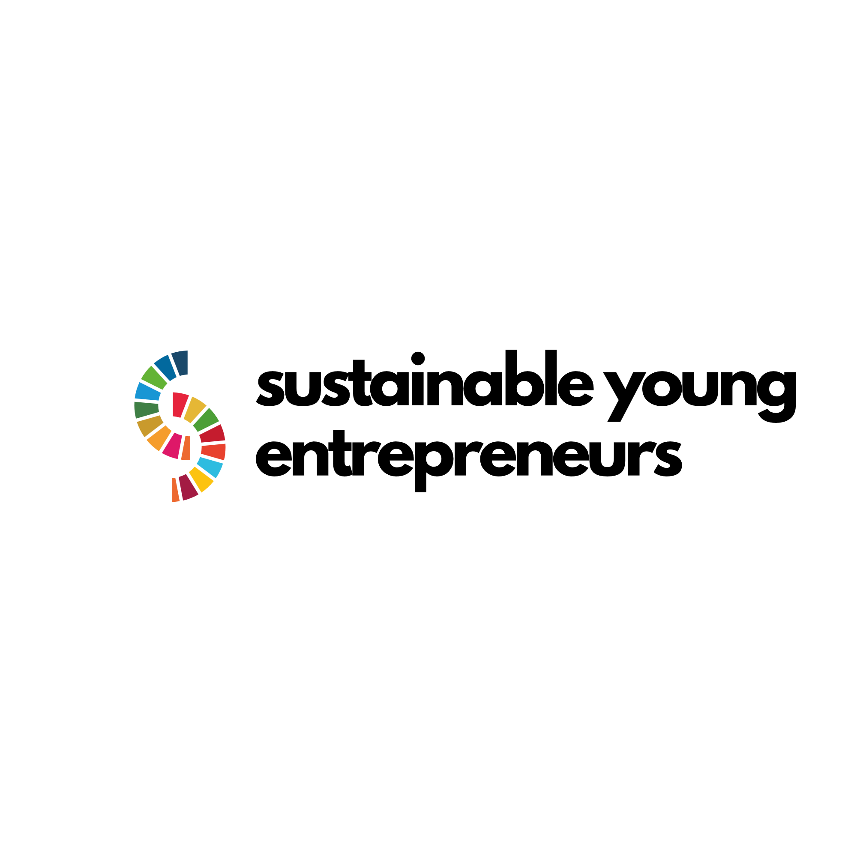

**Sustainable and Social Entrepreneurship for Youth (SUSE) Programme**

**Instruction Guide for Youth Workers**

**Project nr: 2022-2-RO01-KA220-YOU-000102027**

**Document Identity**

|  |  |
| --- | --- |
| **Recipients** | Sustainable and Social Entrepreneurship for Youth partners |
| **Confidentiality Status** | Public |

**Document Versioning**

|  |  |  |
| --- | --- | --- |
| **Version** | **Date** | **Authors** |
| V1 | May 2024 | Katalin Ferencz-Salamon, Rita Both |
| V2 | 24th of May 2024 | Katalin Ferencz-Salamon, Rita Both |
| V3 |  |  |
| V4 |  |  |

This document may change without notice.

All rights reserved. Copyright

© Copyright 2023 Sustainable and Social Entrepreneurship for Youth

**Partner Members:**

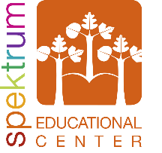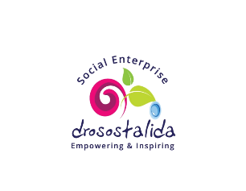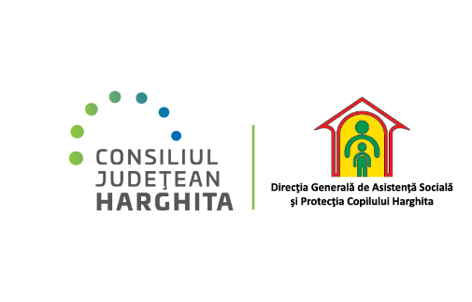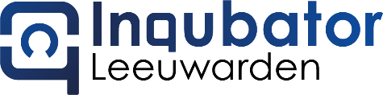

# Content

Content 3

Introduction 4

How to use the training material in order to help young people in the learning process 4

Introduction to the SDGs and their significance in addressing global challenges 6

What are the Sustainable Development Goals and why are they good for us? 6

Why should youth workers care about the SDGs? 7

Integrating the SDGs into youth work 7

Practical Information on Social Entrepreneurship 10

What is a Social Enterprise? 10

SE in practice 10

# Introduction

SUSE is an Erasmus+ project aiming at improving employability to give young people the opportunity to learn about social entrepreneurship, to be self-employed and simultaneously work on environmental issues in society.

Empowering young people is a solid basis for developing sustainable communities and achieving global development aspirations. When young individuals are empowered, they become facilitators for positive transformations within their societies. By investing in their empowerment, communities can use the creativity, energy and talents of young people to address diverse social, economic and environmental challenges. Empowered young people are not only prepared to face complex challenges, but also to stand up for their rights and contribute meaningfully to inclusive and equitable development.

In this context, **youth workers** assume essential roles **as mentors, coaches, trainers and promoters of youth growth and leadership**, they provide educational, social and emotional support, developing essential skills such as communication, teamwork and problem-solving. Through workshops, training initiatives and community projects youth workers can raise awareness of the Sustainable Development Goals (SDGs), stimulating a passion for action among young people, so in addition, they encourage the development of social entrepreneurship, inspiring innovative solutions to local and global problems.

In order to provide an **educational foundation** for **youth workers**, the SUSE consortium offers an **Instruction Guide** for them, which is part of the youth training curriculum developed, with the aim to increase young people self-development skills, to inspire them to start a (social) business, to become self-employed and, by connecting with the local community, to become more active citizens.

The training curriculum developed is a self-learning tool meant for young people. The training itself can be run by a youth worker or, in case of the self-learning process, be guided also by a youth worker. Therefore we, the consortium of the SUSE project, prepared a practical guide for youth workers, which gives them instruction on how to guide youth to learn about the above mentioned topics and on how they can transfer the learning materials.

Through this guide youth workers will learn about:

* Sustainable Development Goals (SDGs) and their significance in addressing global challenges,
* be handed practical information on Social Entrepreneurship (SE) and
* learn how to connect the local community with youth to enhance network opportunities.

## How to use training material to help young people in the learning process

The SUSE curriculum can be delivered in hybrid, online and offline formats to address the needs of the target group.

The training programme is structured in four modules presented in PowerPoint format, accompanied by three guides providing additional information on the topics covered in the modules. The content of the curriculum includes:

Module 1: Introduction to the Sustainable Development Goals (SDGs)

* Relating part of the Interview with Social Entrepreneur, <https://www.youtube.com/watch?v=YsIe6w45-_k&t=1192s> (from 00:00 to 05:00)
* Video introduction to the module: <https://shorturl.at/eJlU1>
* PPT Training Material link: link to the website

Module 2: Social Business Entrepreneurship - mastering its configuration, Social Business Canvas and pricing

* Relating part of the Interview with Social Entrepreneur, <https://www.youtube.com/watch?v=YsIe6w45-_k&t=1192s> (from 05:00 to 06:00)
* Video introduction to the module: <https://shorturl.at/H6TrV>
* PPT Training Material link: link to the website

Module 3: Networking and Communication

* Relating part of the Interview with Social Entrepreneur, <https://www.youtube.com/watch?v=YsIe6w45-_k&t=1192s> (from 11:30 to 15:35)
* Video introduction to the module: <https://shorturl.at/5tTfK>
* PPT Training Material link: link to the website

Module 4: Digital marketing and social media

* Relating part of the Interview with Social Entrepreneur, <https://www.youtube.com/watch?v=YsIe6w45-_k&t=1192s> (from 15:35 to 20:10)
* Video introduction to the module: <https://shorturl.at/4pXQp>
* PPT Training Material link:

Guide 1: Degrading the business environment

Guide 2: Gender equality in business

Guide 3: Digital Tools in Industry 4.0 and 5.0 Shaping Entrepreneurship in the New Digital Society

links to PPTs still to be completed

Before the course starts, it is recommended to watch an interview with Judith Molnár, co-founder of the shop Local products in the right place - Helyénvaló Helyi in Romania: [https://www.youtube.com/watch?v=YsIe6w45-_k.](https://www.youtube.com/watch?v=YsIe6w45-_k)

This video features a real-life social entrepreneur and helps to understand the definition and principles of social entrepreneurship. The structure of the interview aligns with the training modules, allowing viewers to follow an existing social enterprise through the main topics covered.

The integration of practical examples with theoretical content is considered essential in the learning process. It is therefore highly recommended to watch this video before starting the training.

After watching the video, learners can continue independently or with guidance, using the presentations and following the sequence of modules. For those who wish to go deeper into the topics, the guides provide additional resources.

To enable youth workers to effectively support young people's self-learning, the guide introduces the SDGs and social entrepreneurship through **practical** and **self-reflective exercises**. These exercises can be completed **individually by the youth worker** or **collaboratively in groups with young people**.

## Introduction to the SDGs and their significance in addressing global challenges

### What are Sustainable Development Goals and why are they good for us?

The 17 Sustainable Development Goals (SDGs), also known as the "Global Goals", were adopted by the United Nations in 2015 as universal call to action to end poverty, protect the planet and achieve the ambitious goal of peace and prosperity for all by 2030.   
  
Before we get to our concrete actions and scope please visit the following link for a detailed overview of the goals (in English and other international languages), specific indicators and how they are being tracked globally: <https://sdgs.un.org/goals> OR watch the one and a half minute video below to review the 17 development goals: <https://youtu.be/0XTBYMfZyrM?si=KW0OhxFDpsy62Pfv>  
  
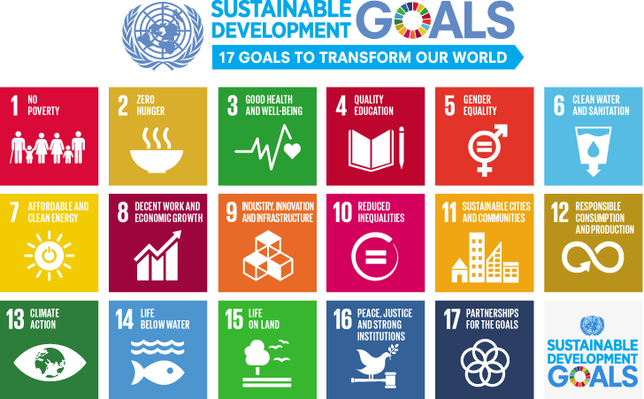

Source of image: <https://sdgs.un.org/goals>

The 17 SDGs are integrated, which means that actions in one area will have an impact on progress in others, and that development must balance social, economic and environmental sustainability. The Sustainable Development Goals are important, world-changing goals that will require cooperation between governments, international organisations and world leaders. From this point of view, it seems impossible for the average person to make an impact in this process, but change starts at the individual level. To illustrate that there are a few easy things we can adopt in our daily lives, routines that, if we all do them together. They will make a big difference.

In the following have a look at the **Lazy Person’s Guide** and reflect on your on habits, to see how your daily actions can contribute to SDGs: <https://www.un.org/sustainabledevelopment/takeaction/>

### Why should youth workers care about the SDGs?

By adopting the SDGs, youth workers can empower the young people to become active agents of change in their communities and beyond. Getting involved in the SDGs enables youth workers to empower the young people they mentor with a sense of purpose and responsibility. By educating young people about the SDGs and involving them in initiatives that contribute to achieving these goals, youth workers can raise a generation of socially conscious leaders who are committed to making a positive difference in the world. SDGs encourage creativity and entrepreneurship, inspiring young people to become change-makers in their own right.

In addition, understanding the SDGs opens up new opportunities for collaboration and innovation. Youth workers can connect with like-minded organisations, government agencies and businesses that are also working towards the SDGs, fostering partnerships that amplify their impact and expand their resources.

### Integrating the SDGs into youth work

In this part of the Instruction guide you will find some practical strategies for incorporating SDG principles into youth programs and activities, and tips for engaging youth in SDG-related projects and campaigns. By implementing these practical strategies and tips, youth workers can effectively incorporate SDG principles into their programs and activities, empowering young people to become active agents of change in their communities and beyond.

Through the following exercises you can easily engage students to participate in SDG related activities.

1. **Foster youth leadership and participation:**

Empower youth to take on leadership roles within SDG-related projects and campaigns, giving them ownership and responsibility for driving change.

Create opportunities for youth to voice their opinions, ideas, and concerns regarding sustainable development issues, ensuring their perspectives are valued and incorporated into decision-making processes.

Exercise:

* Objective: to create digital campaigns to raise awareness about a particular SDG
* Skills enhanced: teamwork, problem solving, communication, critical thinking, digital skills
* Activity: Whether promoting a social cause, a non-profit organization, a product, or a service, or raising awareness about (social, economic, environmental) sustainability issues, a well-executed digital campaign can help to reach a wide audience.

Ask students to create digital campaigns to raise awareness about a particular SDG they are interested in. Form groups of 4-5 students based on their SDG interest and present them several forms of **Digital SDG awareness campaigns**, which can be **created through different platforms** to reach a wide audience:

* social media campaigns on Facebook, Twitter, and Instagram to share information, stories, infographics, and videos related to specific SDGs;
* online webinars and workshops on platforms like Zoom, Microsoft Teams, or dedicated webinar software can be used for this purpose;
* podcasts offer a more in-depth and personal way to engage with the audience and can be distributed on platforms like Apple Podcasts, Spotify, or Google Podcasts;
* email campaigns, for this purpose they can use different email marketing platforms, like MailChimp for targeted email campaigns to subscribers or stakeholders, featuring information about specific SDGs, progress updates, and calls to action;
* online challenges or competitions that encourage individuals to make sustainable choices or take actions related to the SDGs, such as reducing waste, conserving energy, or supporting local communities;
* online competitions related to the SDGs, such as hackathons, innovation challenges, or essay contests, to encourage creativity and problem-solving;
* partnerships with influencers: collaborate with social media influencers, celebrities, and thought leaders who have a strong online presence to amplify the message of the SDGs to their followers.

Ask groups of students to choose which type of digital awareness campaign they would like to create and on what platform. The choice of campaign type should be adapted to the specific SDGs, target audience, available resources and desired impact. A combination of several campaign types can also be used to maximise reach and engagement. Open up for working groups to share their campaigns’ results, experiences and lessons learnt.

* Materials needed: digital devices, internet connection

1. **Promote collaboration and partnerships:**

* Foster collaboration between youth organizations, schools, NGOs, government agencies, and businesses to implement joint SDG projects and initiatives.
* Engage with local community stakeholders to identify shared priorities and develop collaborative solutions that address specific SDG targets.
* Encourage cross-sectorial partnerships that leverage the expertise, resources, and networks of different organizations to maximize impact and sustainability.

Exercise:

* Objective: to understand the complexity of SDGs, the issues that need to be considered in city planning and awareness on the importance of civic engagement.
* Skills enhanced: teamwork, problem solving, communication and collaboration, networking, interpersonal
* Activity: Ask young people what they like/dislike about their cities (or neighbouring cities, if they live in a village). Watch this animated video together: <https://www.youtube.com/watch?v=-Bqx2BuFjik>

Ask young people to take notes of the urban challenges mentioned in the video that they can experience in their own cities. After watching the video, ask the working groups to come up with 5 suggestions on how to make their cities sustainable. Ask them to present their ideas on a flipchart and to give constructive feedback to the ideas of the other groups.

After the presentations, ask young people to vote for the 10 best ideas and to consider sharing these ideas with their local municipality/ representatives.

* Materials needed: digital devices, internet connection.

1. **Use Innovative Communication and Outreach Strategies:**

Use digital platforms, social media, and multimedia tools to raise awareness about the SDGs and engage youth in meaningful conversations about global challenges.

Organize interactive workshops, hackathons, and creative competitions that inspire youth to develop innovative solutions to SDG-related issues.

Employ storytelling techniques and real-life examples to make the SDGs more relatable and accessible to young audiences, showcasing the positive impact of individual and collective action.

Exercise:

* Objective: Raise awareness on SDGs using Digital Storytelling
* Skills enhanced: teamwork, problem solving, communication and collaboration, networking, interpersonal, digital skills
* Activity: Challenging students to tell stories related to SDGs, using various digital media is a creative and engaging way to encourage their awareness and involvement in global issues.

First step would be to select the SDG. Let your students choose one or more SDGs to focus on. This allows them to work on issues they are passionate about and aligns with their interests. Put your students in teams of 4-5, according to their area of interest. Ask them to define the objectives of the challenge in small groups, such as raising awareness, advocating for change, inspire action or proposing solutions.  Each group should choose a digital tool to tell their story, this could include videos, podcasts, social media campaigns, blogs, infographics or any other digital format they feel comfortable with. Youth workers should guide students in creating their stories, by emphasising the importance of a compelling narrative, including a clear problem, solution, and a call to action. In order to be credible stories, they should include relevant data and statistics to support their stories. This gives credibility to their stories. For example, They could use stories of role models from their region, which could be individuals sharing their own stories of civic engagement success or local actors.

Encourage young people to provide feedback to their peers during the creative process. This can help improve the quality and impact of their digital media projects. As soon as the digital stories are ready, young people can present their digital media projects to the whole group or you can encourage them to share their projects with a broader audience, potentially through school-wide or community-wide events or through online platforms. After finishing the challenge, facilitate discussions in the classroom to reflect on the experience and consider their next steps in addressing the SDGs.

* Materials needed: digital devices, internet connection

# Practical Information on Social Entrepreneurship

## What is a Social Enterprise?

A social enterprise or social business is defined as a business with specific social objectives that serve its primary purpose. Social enterprises seek to maximize profits while maximizing benefits to society and the environment, and the profits are principally used to fund social programs.

The concept of a social enterprise was developed in the U.K. in the late 1970s to counter the traditional commercial enterprise. Social enterprises exist at the intersection of the private and volunteer sectors. They seek to balance activities that provide financial benefits with social goals, such as housing for low-income families or job training.

Funding is obtained primarily by selling goods and services to consumers, although some funding is obtained through grants. Because profit-maximization is not the primary goal, a social enterprise operates differently than a standard company.

While earning profits is not the primarymotivation behind a social enterprise, revenue still plays an essential role in the venture's sustainability. [Sustainable revenue](https://www.investopedia.com/terms/s/sustainablegrowthrate.asp) differentiates a social enterprise from a traditional charity that relies on outside funding to fulfil its social mission. This goal does not mean social enterprises cannot be profitable. Instead, it's simply that their priority is to reinvest profits into their social mission rather than fund payouts to shareholders.

### SE in practice

**Self-definition and principles of a real-life social entrepreneur** (video interview with Judith Molnár, one of the founders of Local Products at their Right Place – Helyénvaló Helyi - shop from Romania).

**Good Practices from around the world**

* Check out international social enterprise ideas on Kickstarter: <https://www.kickstarter.com/discover/advanced?ref=nav_search&term=social%20enterprise>

Here you can find fresh new ideas of social enterprises that are looking for a seed fund to get started.

* Watch videos of international social enterprises already in business on YouTube:

8 Social Enterprise Examples for 2023: <https://www.youtube.com/watch?v=WgJ9ZDVgj2o>

Our Story: Social Enterprise in Action: <https://www.youtube.com/watch?v=VpRSe0dGo98>

Coffee United a social enterprise dedicated to better lives: <https://www.youtube.com/watch?v=GQ23ey-KqDc>

A Social Enterprise that inspires young people to think big and get creative: <https://www.youtube.com/watch?v=yoCTrZTp5v8>

Doon Social Farm #SICAPStory: <https://www.youtube.com/watch?v=dmXzpr37mX8>

**Local Good Practices** (Field Trips)

When organizing a field trip with young people to visit local social enterprises, there are several key aspects to consider to ensure the experience is educational, engaging, and safe. Here are some points to pay attention to:

* Planning and preparation

Objective setting: Define clear objectives for the trip. What do you want young people to learn about the social enterprise? Understanding their business model, their impact on the community, or specific operational practices can be focal points.

* Research and selection

Choose social enterprises that align with your educational goals. Make sure that they are reputable and have experience with working with visitors and study groups.

* Pre-trip briefing

Prepare the young people with information about the enterprise they are going to visit.

* After the trip – reflection after the field trip.

Take time to reflect and discuss together what they have learnt about the different aspects of the social enterprise. For this purpose you can use the **List of criteria** they followed during the fieldtrip:

TEMPLATE

Possible criteria for local SE visits

1. Background and role: who is the SE representative, and what is his/her current role within the social enterprise?
2. Inception of enterprise: what motivated them to start their enterprise? What needs or gaps were they aiming to fill?
3. Significant achievements: what are the milestones or recognitions they have achieved?
4. Alignment with SDGs: which of the SDGs that specific enterprise target and why?
5. Impact measurement: what methods do they use to measure their organization’s impact, especially regarding the SDGs?
6. Successful practices: did they mentioned any examples of initiatives that have successfully completed to achieve their social goals?
7. Challenges faced: what major challenges has their enterprise encountered and how have they addressed them?
8. Advice for new entrepreneurs: what advice did they give to the youngsters?
9. Importance of communication: do they have an effective communication strategy? If yes, what is it?
10. Impact of networking: how do they benefit from networking? Are there particular networks that have been invaluable from their point of view?
11. Effective tools and platforms: what tools or platforms have they found most effective for communication and networking?
12. Engaging content types: what types of content have been most effective for engaging their target audience?
13. Choice of digital platforms: how do they choose the appropriate digital platforms for promoting their SE content?
14. Influence of digital marketing: how has digital marketing influenced the growth and outreach of their enterprise?
15. Effective strategies: what digital marketing strategies have they used?
16. Measuring success: how do they measure the effectiveness of their digital marketing efforts?
17. Identifying the target audience: how does that specific SE identify and understand their target audience?
18. Setting objectives: what are the key objectives a digital marketing plan should aim to achieve for a social enterprise?

**Group Activities**

These activities are designed to encourage creativity, collaboration, and critical thinking, essential for brainstorming and developing a robust **social enterprise concept**.

The exercises are intended to be done in the order provided as their results help to work on the next one.

1. **Fishbowl Exercise - Introductory brainstorming to find an idea for a social enterprise**

* Objective: Foster deep dialogue and insights on key issues related to the social enterprise.
* Skills enhanced: Teamwork, problem solving, communication, critical thinking, interpersonal skills
* Activity: Arrange chairs in an inner circle (the fishbowl) and an outer circle. Participants in the inner circle discuss the topic of setting up a social enterprise while those in the outer circle listen. Rotate participants to ensure everyone contributes.
* Materials needed: Chairs, list of discussion topics. Downloadable SDG icons: <https://www.un.org/sustainabledevelopment/news/communications-material/>

1. **Stakeholder mapping – visualize how your social enterprise would help the community**

* Objective: Visualize and understand how the various stakeholders are involved in and affected by the social enterprise.
* Skills enhanced: teamwork, problem solving, communication, critical thinking, interpersonal skills
* Activity: Create a map with all possible stakeholders and discuss their involvement and how to engage them in the social enterprise.
* Materials needed: Flipchart paper, different coloured markers

1. **Elevator Pitch Development – develop your idea in a marketable way**

* Objective: Craft and refine a compelling elevator pitch for the social enterprise.
* Skills enhanced: teamwork, communication, critical thinking, interpersonal skills
* Activity: Select 2 people from the participants to form a three-person jury together with the youth worker. Depending on the number of participants, the rest of the participants can work alone or they can form small teams. Each participant or small team develops a 60-second pitch to present their ideas for social enterprise. They present pitches to the group for feedback and refine them based on suggestions. They have to keep in mind to formulate their ideas in a way to be able to impress the jury in 60 seconds.
* Materials needed: paper, pen, flipchart paper, markers, timer

1. **Role-Playing scenarios – try out your idea**

* Objective: Explore different stakeholder perspectives and potential challenges
* Skills enhanced: teamwork, problem solving, communication, critical thinking, interpersonal skills, adaptability
* Activity: Assign roles to participants (e.g. customer, investor, community member) and present a scenario related to the social enterprise. Each participant discusses their viewpoint and suggests solutions.
* Materials needed: Role cards, scenario descriptions

**Tips on training delivery – outreach, engagement, training delivery (lessons learnt from pilots)**

will be developed based on feedback from the pilots.